# **How to Install Python on Windows [Pycharm IDE]**

PyCharm is a cross-platform editor developed by JetBrains. Pycharm provides all the tools you need for productive Python development.

Below are the detailed steps for installing Python and PyCharm

## **Installing Python**

**Step 1)** To download and install Python visit the official website of Python http://www.python.org/downloads/ and choose your version. We have chosen Python version 3.6.3

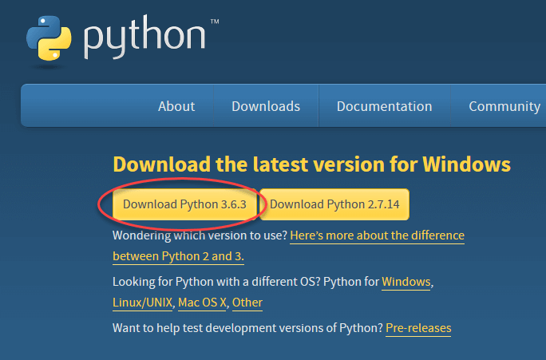

**Step 2)** Once the download is complete, run the exe for install Python. Now click on Install Now.

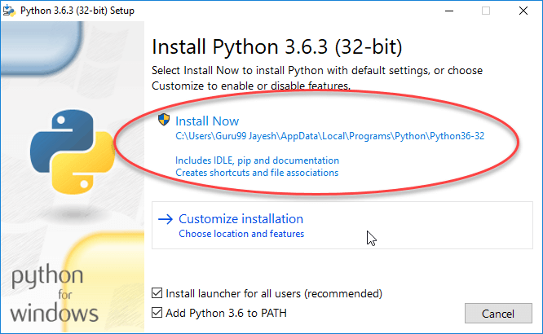

**Step 3)** You can see Python installing at this point.

## **Installing Pycharm**

**Step 1)** To download PyCharm visit the website https://www.jetbrains.com/pycharm/download/ and Click the "DOWNLOAD" link under the Community Section.

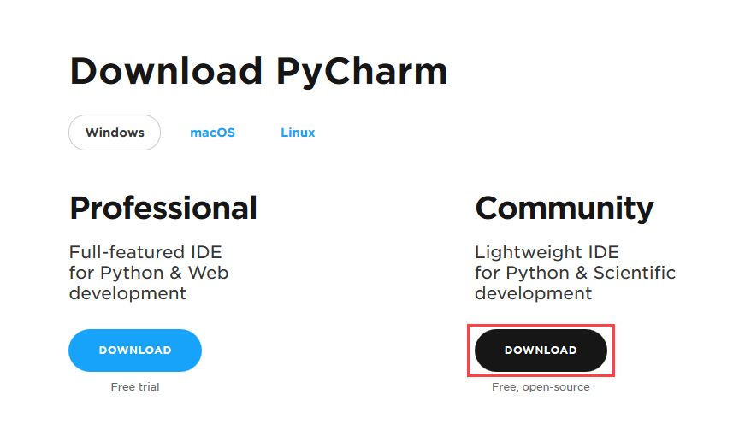

**Step 2)** Once the download is complete, run the exe for install PyCharm. The setup wizard should have started. Click “Next”.

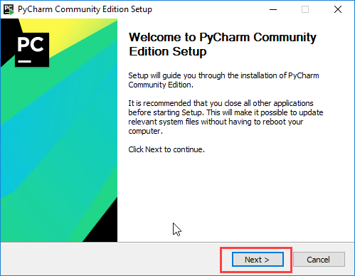

**Step 3)** On the next screen, Change the installation path if required. Click “Next”.

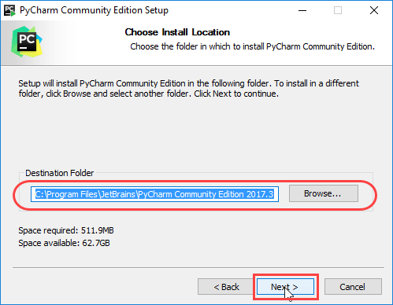

**Step 4)** On the next screen, you can create a desktop shortcut if you want and click on “Next”.

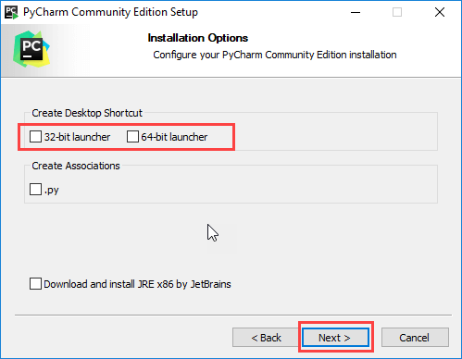

**Step 5)** Choose the start menu folder. Keep selected JetBrains and click on “Install”.

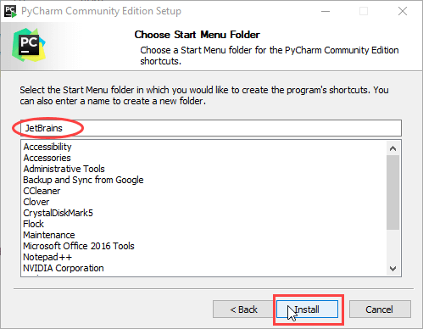

**Step 6)** Wait for the installation to finish.

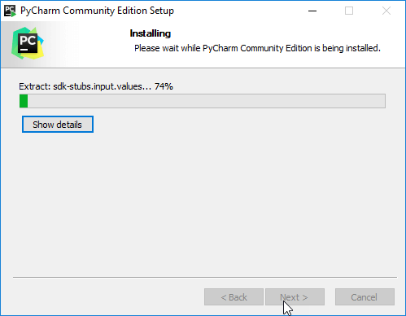

**Step 7)** Once installation finished, you should receive a message screen that PyCharm is installed. If you want to go ahead and run it, click the “Run PyCharm Community Edition” box first and click “Finish”.

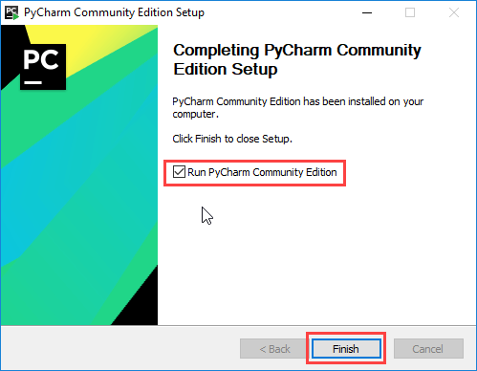

**Step 8)** After you click on "Finish," the Following screen will appear.

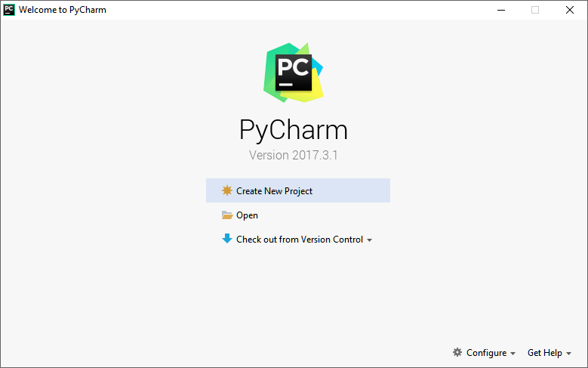

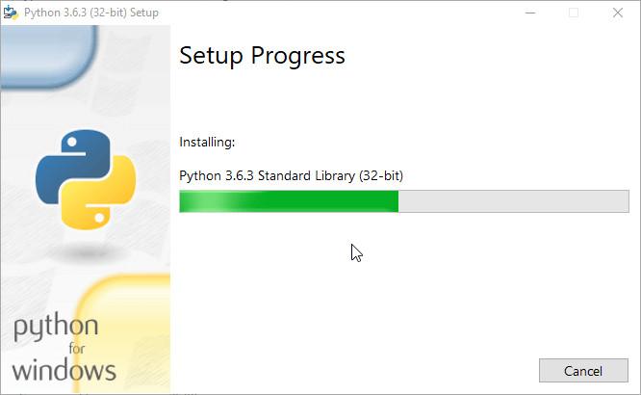

**Step 4)** When it finishes, you can see a screen that says the Setup was successful. Now click on "Close".

